Craig Salins of Washington Public Campaigns
Will speak on:
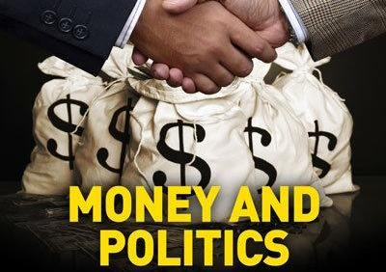
The issue of money in politics this year is of high concern, and touches nearly every other issue we all care about. Join us for an evening with Craig Salins from Washington Public Campaigns.

Craig's presentation with touch on Money As Speech, the Citizens United ruling, campaign finance reform and the logistics of public campaigns. There will be plenty of time for question and answer.

This event is free and open to the public. We look forward to seeing you there!

Bellingham Herald Building, 1155 North State St. Suite 309
Monday, July 9, 2012 7pm - 9pm
Sponsored by WeWillNotBeDivided.org

